- Created VPC
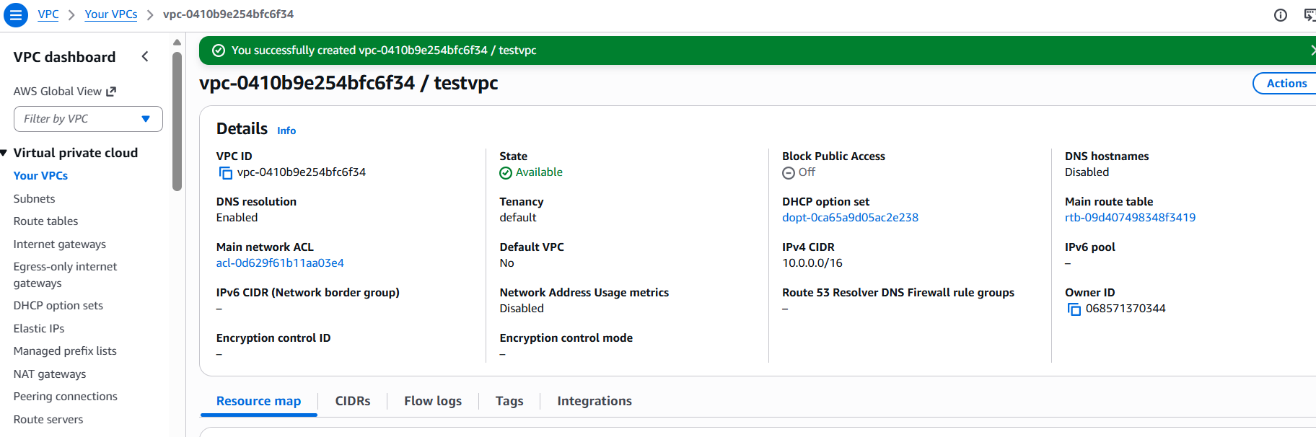
- Created internet Gateway and attached to VPC
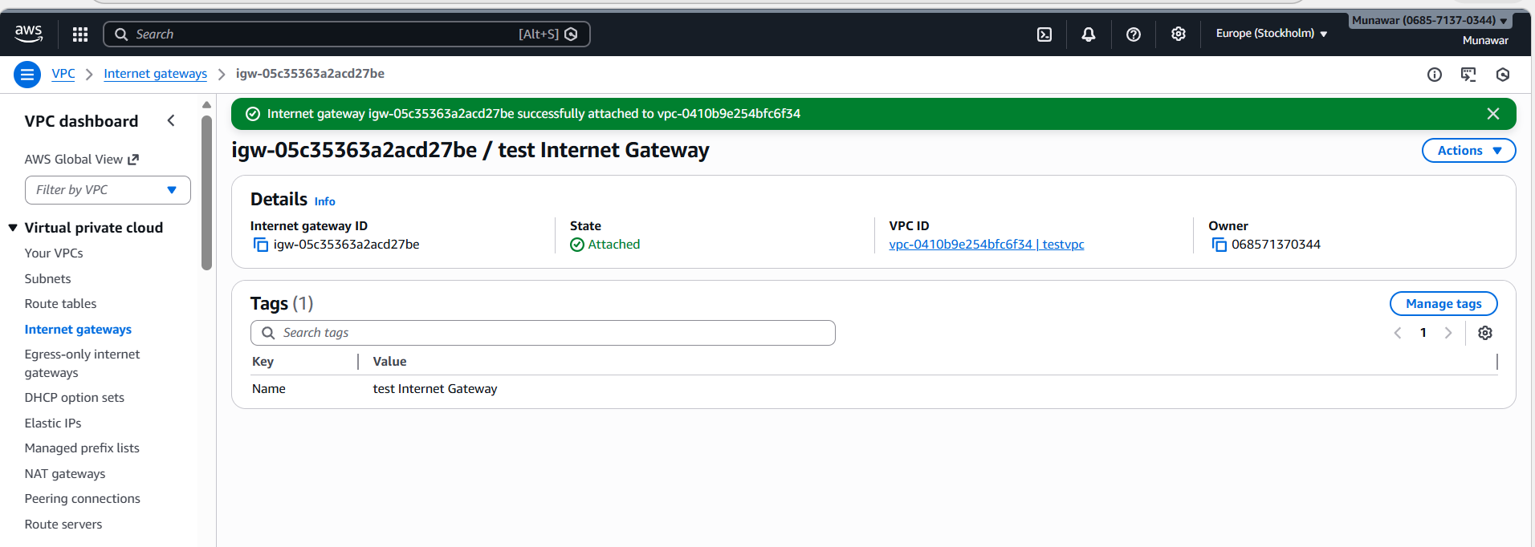
3.Created two subnets
1 .Testsubnet
2.test2subnet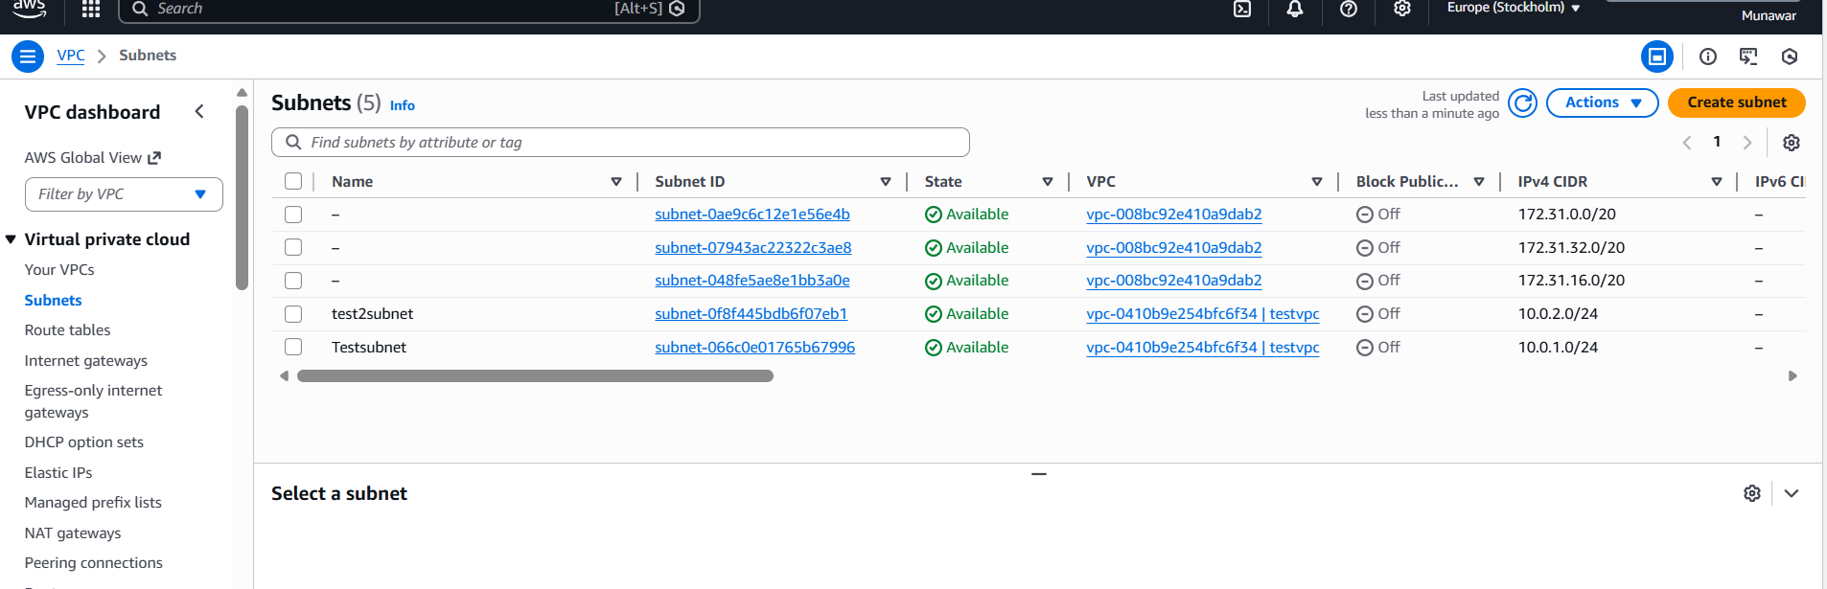
4. Created two routetable
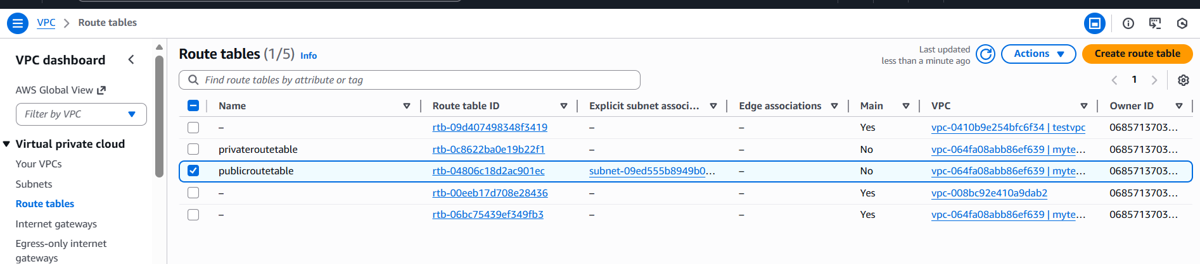

5. Launched EC2 linux server